**Assignment 4 (21-22)**

**Report Section: Assessment of the tTEM Method for Use at the Study Site**

**Canvas submission due: Tuesday May 17, before class**

You will first work through PART A: “Learning the Basics” given below. Include the answers to the questions in PART A as an appendix to your report. Then you will write the report section, as described in PART B.

# **PART A: tTEM – Learning the Basics of Forward Modeling**

In this part of the assignment, we are going to learn fundamentals about a towed time-domain EM (tTEM) survey. For a hydrogeologic setup, we are going to consider an area below the water table, with two sediment types: clay and sand; their resistivity values are given in the Table at the end. A layer (either sand or clay) is embedded in a background of the other material as shown in the image below. Depth to the layer is z and thickness of the layer is h.

Figure 1

Important concepts that we are going to learn are:

* Excitation of the subsurface
  + Principle of electromagnetic (EM) wave propagation
  + Effect of a background resistivity
* Current waveform - dual moment system
  + What is the benefit of the dual moment system?
* Detectability of the layer
  + How do we define detectability?
  + Can we see the target layer?
  + For a given thickness of a layer what is the maximum depth that can be detected by the tTEM data?
* Non-uniqueness
  + Equivalent conductance (i.e., layer thickness multiplied by 1/resistivity)
  + Saturation of resistivity

**Numerical tools**

Numerical tools will be provided such that you can explore the above concepts. We will use Jupyter Notebooks, an interactive coding platform, to run Python codes. These notebooks are available through a github repository: <https://github.com/sgkang/gp190_ttem_forward>. Two notebooks that we are going to use are:

1. TDEM_HorizontalLoop_LayeredEarth.ipynb
2. ttem_forward_modelling.ipynb

# **Please answer the following questions and include your answers as an Appendix to your report section.**

# Excitation of the subsurface

Q1: Describe how an EM wave propagates when a step-off current is injected in a source loop of the tTEM system; use Faraday’s law and Ampere’s law.

Q2: In order to propagate the EM energy into the subsurface, the source loop is not required to be in contact with the ground. Explain the physical reason, and discuss how this can be a benefit for an EM experiment.

Q3: Set a homogeneous half-space resistivity (i.e., the subsurface resistivity is homogeneous) as 20 𝛀m, and plot the current density at 0.06 ms (i.e. Time index=20). Change the resistivity value to 50 𝛀m and plot the current density at the same time (i.e., 0.06 ms). What do you observe? What can you infer about the velocity of the EM wave with regard to the homogenous resistivity value?

## Current waveform

Q4: tTEM system is composed of the low moment and the high moment. What is the benefit of this dual modment system compared to a single moment system?

Q5: If you want to see deeper, which of the following parameters associated with the transmitter would you increase? Choose multiple answers.

1. Number of turns of transmitter coils
2. Amplitude of the transmitter current
3. Size of the transmitter loop
4. Pulse width
5. Ramp-off time

## Detectability of the layer

We define detectability of the layer as

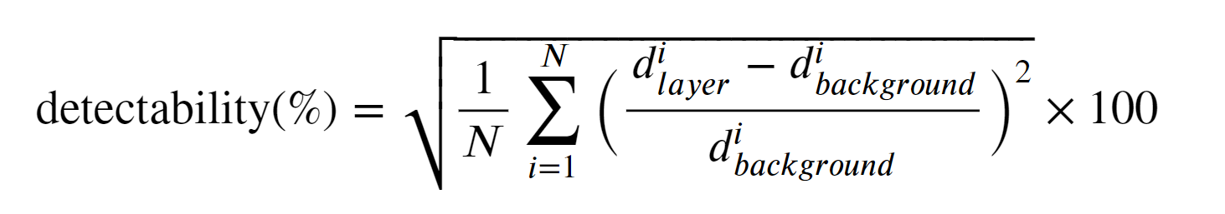

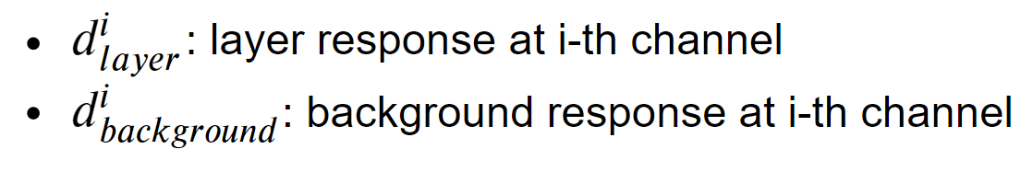

For answering following questions, we will use a function ttem_forward_modelling in ttem_forward_modelling.ipynb.

Q6: Calculate the detectability by filling a function, calculate detectability of the tTEM data using ttem_forward_modelling for two cases: 1) z=10 m, h=10 m, sand layer embedded in clay background; 2) z=10 m, h=10 m, clay layer embedded in sand background, and report the values. Which one is greater?

Q7: Consider the clay layer embedded in sand background, and calculate a detectability value for a variable z ranging from 1-100 m. Plot the detectability as a function of z. Suppose 5% is the noise level in the tTEM data, what is the maximum depth that the layer is detectable? Repeat the same process for the sand layer embedded in clay background, and compare the resulting detectability curves.

## Non-uniqueness

Q8: Calculate the tTEM data for each case in the below; fill in empty cells in the table; plot resulting decay curves; a clay layer is embedded in sand background. Are they different or similar? What can you infer from these results?; think about in the context of an inverse problem - finding a resistivity model that can fit the tTEM data.

|  |  |  |  |  |  |
| --- | --- | --- | --- | --- | --- |
|  | z (m) | h (m) | 𝝆_clay (𝛀m) | h x 1/𝝆_clay | detectability |
| Case 1 | 30 | 1 | 4 |  |  |
| Case 2 | 30 | 2 | 8 |  |  |
| Case 3 | 30 | 4 | 16 |  |  |

Q9: Calculate the tTEM data for each case in the below; fill in empty cells in the table; plot resulting decay curves; a sand layer is embedded in clay background. Are they different or similar? What can you infer from these results?; think about in the context of an inverse problem - finding a resistivity model that can fit the tTEM data.

|  |  |  |  |  |
| --- | --- | --- | --- | --- |
|  | z (m) | h (m) | 𝝆_sand (𝛀m) | detectability |
| Case 1 | 30 | 10 | 17 |  |
| Case 2 | 30 | 10 | 25 |  |
| Case 3 | 30 | 10 | 50 |  |
| Case 4 | 30 | 10 | 100 |  |

**PART B: Report Section - Assessment of the tTEM Method for Use at the Study Site**

Now that you’ve learned the basics of tTEM, you’re ready to assess the use of tTEM to answer your defined Key Questions at the study site.

Write a short introduction (4-5 sentences) outlining the tTEM method and how it can be used for near surface applications.

Explain why a tTEM survey would or would not be useful in addressing the Key Questions you have defined for the study site. Discuss capabilities and limitations of tTEM, using what you learned by answering the questions in PART A above. If there are important figures resulting from PART A, that are supporting points you are making in the report section, please repeat these figures in the report section. Feel free to repeat some of the modeling done in PART A to consider specific scenarios relevant to the questions you wish to address.

**TABLE OF RESISTIVITY VALUES**

|  |  |
| --- | --- |
| Dry sand and gravel | 44-150 Ohm-m |
| Wet sand and gravel | 17-43 Ohm-m |
| Wet clay | 6-16 Ohm-m |
| Sandstone/siltstone | 25-100 Ohm-m |
| Serpentinite | 50-100 Ohm-m |